1. Start XAMPP Control Panel: Open the XAMPP Control Panel. You can usually find it in the installation directory or by searching for "XAMPP Control Panel" in your Start menu and open it.



1. Start MySQL: In the XAMPP Control Panel, click on the "Start" button next to the MySQL module. This will start the MySQL server.

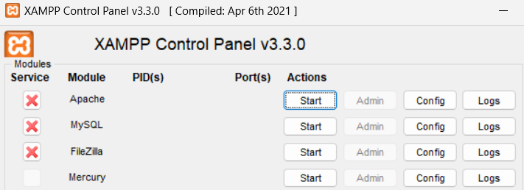

1. Open phpMyAdmin: Click on the "Admin" button next to the MySQL module in the XAMPP Control Panel. This will open phpMyAdmin in your default web browser.

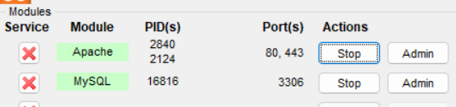

1. Create a Database: In phpMyAdmin, click on the "Databases" tab in the top menu. Enter a name for your database in the "Create database" field and click the "Create" button.

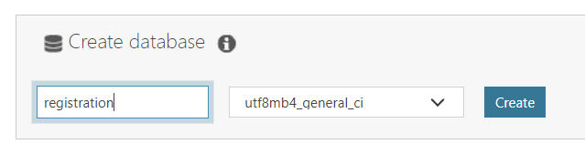

1. Create a Table: Click on your database, give the table name and click the "Create" button.

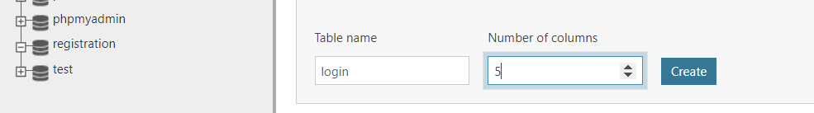

1. Table Structure: Give the column name and click the "Save" button.

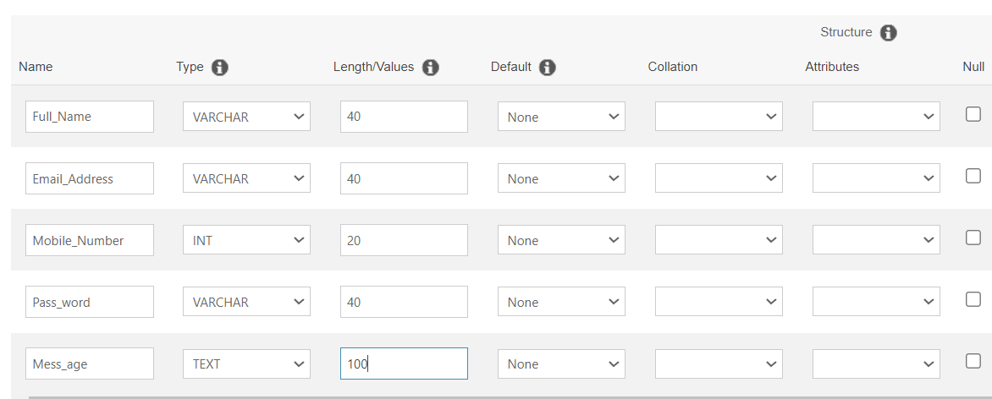

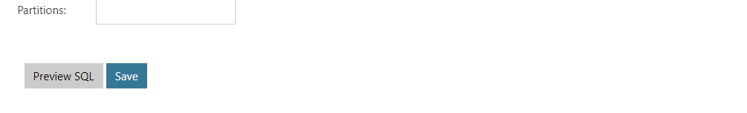

1. Create files: Go to the htdocs folder and here I am creating a folder which name is mysql and inside of this I am creating form.html, dataInsert.php and selectdata.php

htdocs

mysql

form.html

dataInsert.php

selectdata.php

* Input: insert given code in form.html file.

|  |
| --- |
| <!DOCTYPE html>  <html lang="en">  <head>      <meta charset="UTF-8">      <meta http-equiv="X-UA-Compatible" content="IE=edge">      <meta name="viewport" content="width=device-width, initial-scale=1.0">      <title>Document</title>       <!-- Bootstrap Link -->    <link href="https://cdn.jsdelivr.net/npm/bootstrap@5.0.2/dist/css/bootstrap.min.css" rel="stylesheet"    integrity="sha384-EVSTQN3/azprG1Anm3QDgpJLIm9Nao0Yz1ztcQTwFspd3yD65VohhpuuCOmLASjC" crossorigin="anonymous">  <!-- Bootstrap Link -->  </head>  <body>                  <h5 class="modal-title" id="exampleModalLabel">Registration</h5>                  <div class="modal-body">                <form action="dataInsert.php" method="post">                  <div class="form-group" style="margin-bottom: 20px;">                    <label for="fullName">Full Name</label>                    <input type="text" name="full_name" id="fullName" placeholder="Enter your full name" required="">                  </div>                  <div class="form-group" style="margin-bottom: 20px;">                    <label for="emailid">Email Address</label>                    <input type="email" name="email" id="emailid" placeholder="Enter your email address"                      required="">                  </div>                    <div class="form-group" style="margin-bottom: 20px;" required="">                    <label for="mobileNo">Mobile Number</label>                    <input type="tel" name="mobile_No" id="mobileNo" placeholder="Enter your mobile number" required="">                  </div>                  <div class="form-group" style="margin-bottom: 20px;">                    <label for="pass">Password</label>                    <input type="password" name="password" id="pass" placeholder="Create Password" required="">                  </div>                  <div class="form-group" style="margin-bottom: 20px;">                    <label for="mess">Message</label>                    <input type="text" name="message" id="mess" required="">                  </div>                    <button type="submit" class="btn btn-warning">Submit</button>                </form>              </div>    </body>  </html> |

* Input: insert given code in dataInsert.php file.

|  |
| --- |
| <?php  if($_SERVER["REQUEST_METHOD"]=="POST"){       $serverName = "localhost";     $username = "root"; // Username Name     $pass = "";     $dbName = "registration";    // Databases Name     $conn = mysqli_connect($serverName, $username, $pass, $dbName);  if($conn == false){      die("Error". mysqli_connect_error());    }  else{    $fullName = $_POST["full_name"];  $email_id = $_POST["email"];  $mobile_no = $_POST["mobile_No"];  $password = $_POST["password"];  $mess = $_POST["message"];    $sql = "INSERT INTO `login` (`Full_Name`, `Email_Address`, `Mobile_Number`, `Pass_word`, `Mess_age`) VALUES ('$fullName', '$email_id', '$mobile_no', '$password', '$mess')";  $result = mysqli_query($conn, $sql);  if($result){      echo "record added";  }else{      echo "some issues";  }  }  mysqli_close($conn);  }  ?> |

* Input: insert given code in selectdata.html file.

|  |
| --- |
| <?php  $servername = "localhost";  $username = "root";  $password = "";  $dbname = "registration";  // Create connection  $conn = mysqli_connect($servername, $username, $password, $dbname);  // Check connection  if (!$conn) {      die("Connection failed: " . mysqli_connect_error());  }  $sql = "SELECT Full_Name, Email_Address FROM login";  $result = mysqli_query($conn, $sql);  if (mysqli_num_rows($result) > 0) {      // output data of each row      while($row = mysqli_fetch_assoc($result)) {          echo "Name: " . $row["Full_Name"].  "<br>Email:" . $row["Email_Address"]. "<br><br>";      }  } else {      echo "0 results";  }  mysqli_close($conn);  ?> |

**Note:**

<input type="text" name="full_name" id="fullName" placeholder="Enter your full name" required="">

Into the form, we are defined name for the input field. It it used to identify the field when the form is submitted.

$fullName = $_POST["full_name"];

In PHP, into the insertdata.php file

$_POST is superglobal.

In this case, the code assigns the value of the “full_name” input field to the PHP variable ‘$fullName’. Corresponds to the ‘name attribute of the input field in the HTML form, By accessing $_PODT[“Full_name”], this code returns the value entered by the user in the “full_name” input field.

$sql = "INSERT INTO `login` (`Full_Name`, `Email_Address`, `Mobile_Number`, `Pass_word`, `Mess_age`) VALUES ('$fullName', '$email_id', '$mobile_no', '$password', '$mess')";

The SQL query begin with the ‘INSERT INTO’ statement, specifying the table name (‘login’) to which the data will be inserted.

Column name

(`Full_Name`, `Email_Address`, `Mobile_Number`, `Pass_word`, `Mess_age`)

‘Values’ keyword is used to specify the values to be inserted into the respective coloumns.

The values are provoded as variable wrapped in single quotes ('$fullName', '$email_id', '$mobile_no', '$password', '$mess')";

1. Open phpMyAdmin: Click on the "Admin" button next to the Apache module in the XAMPP Control Panel. This will open phpMyAdmin in your default web browser and search mysql.



1. You need to just click on form.html and field data and click on submit you get a record add output. 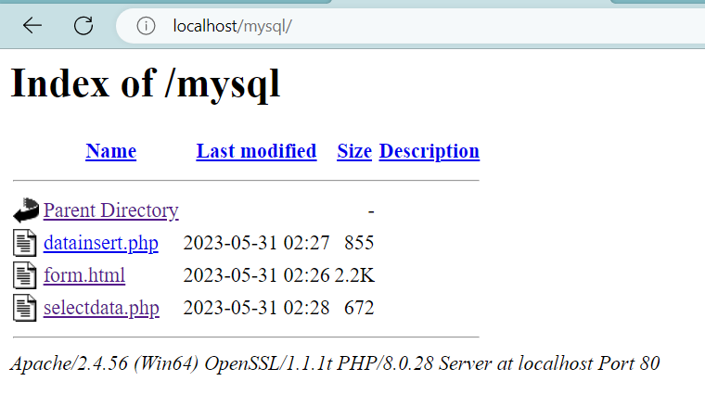

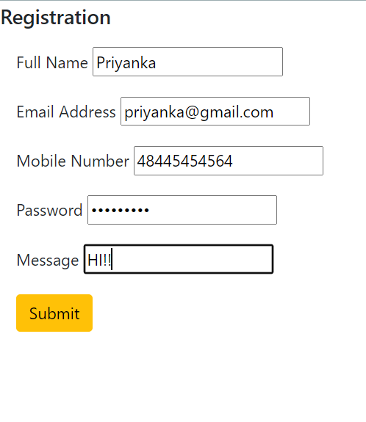

Output:

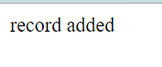

1. Go to MySQL and click on admin.

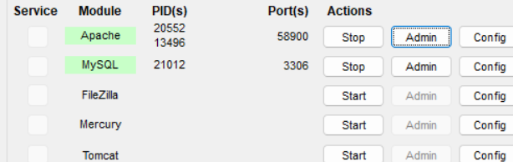

1. Click on registration then click on login, there you can see the record

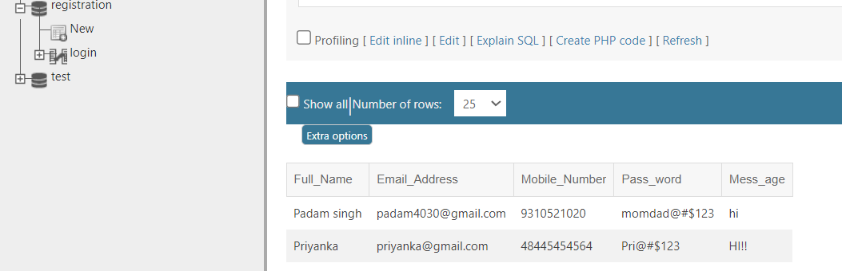

1. If you want to see record on browser with php code just click on selectdata.php you see the ouput as below.



Know we are successfully create connection with mongodb and mysql.